Flow chart

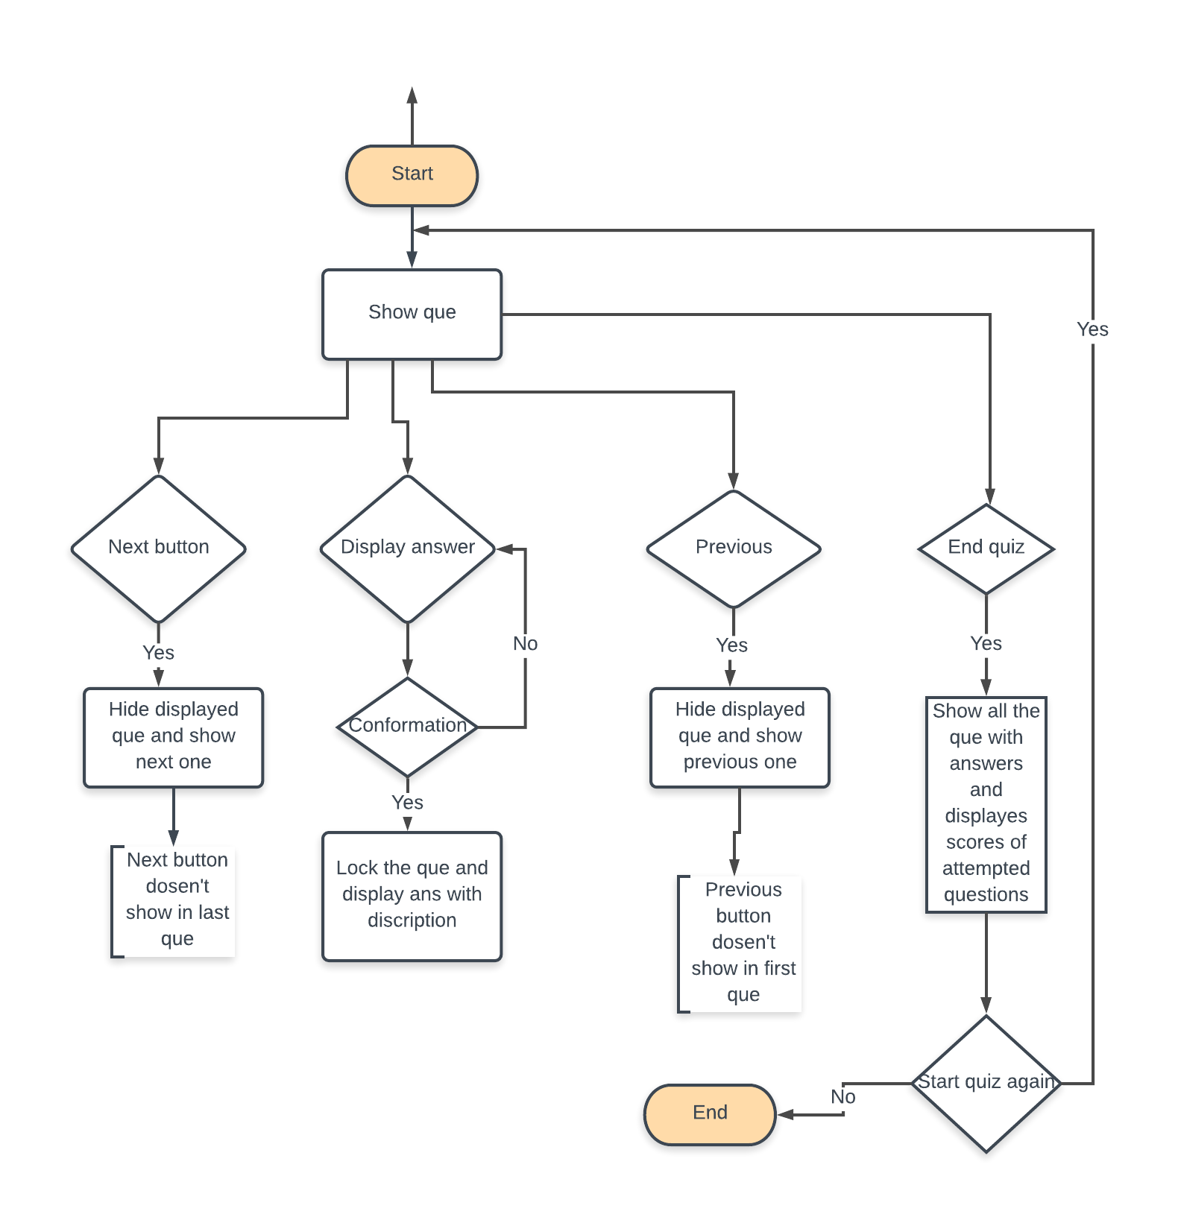

* All question and Ans are stored in divs
* Used a hide and show method in js to make a slide show
* Radio button, textbox’s and buttons